**Assignment 7.6**

**Problem Statement:**

Write a map reduce program save the output of the word count program in XML format. You need to write a custom writable to save the output in XML format.

Note : You can use any data set of your choice for executing this program.

**Input:**

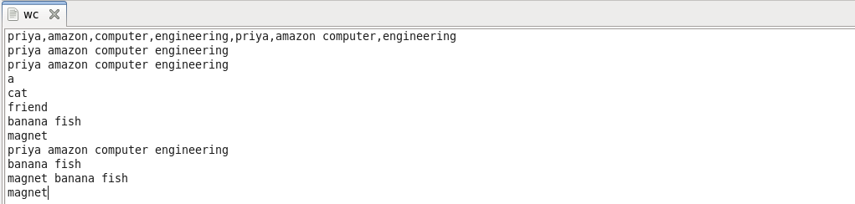

**Program:**

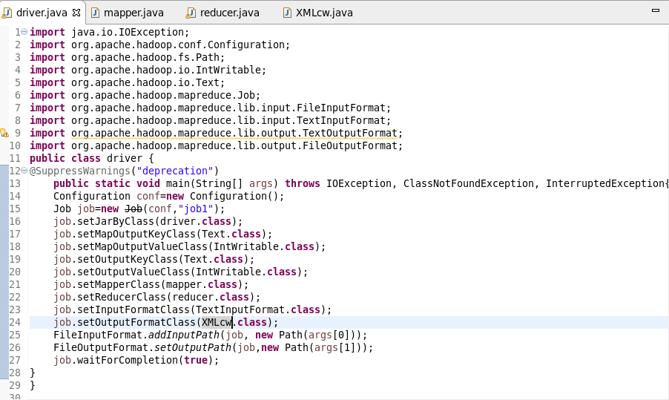

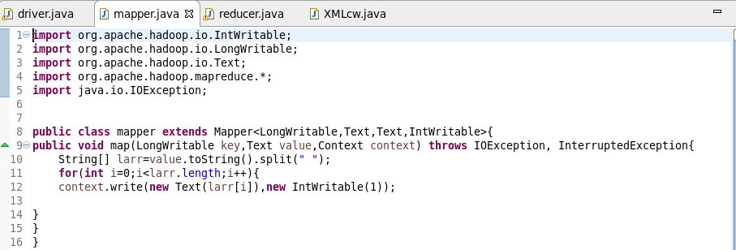

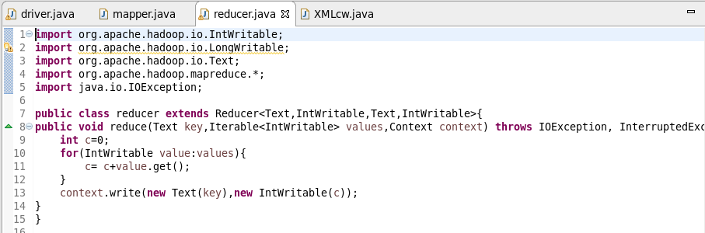

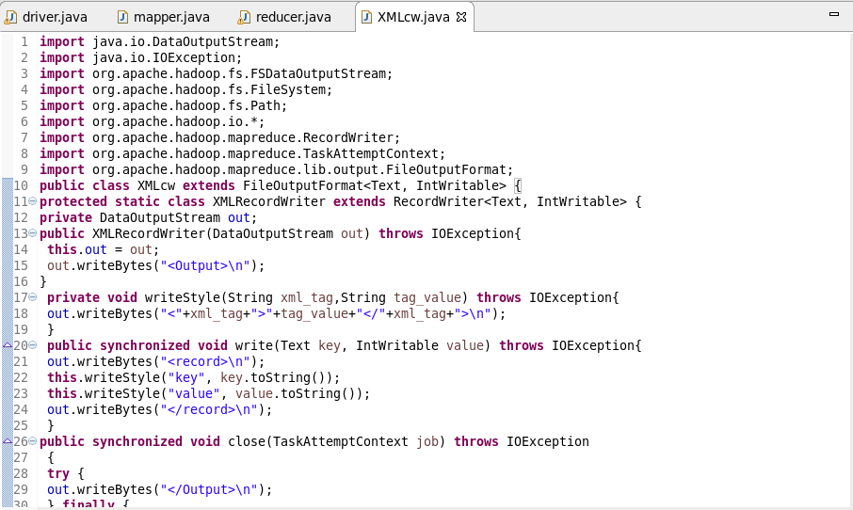

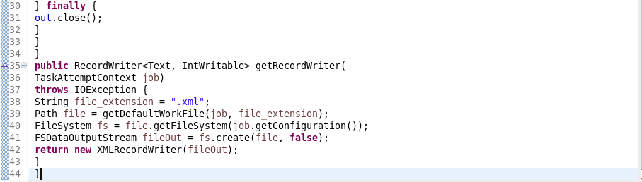

**Output:**

